**GVC PROJECT**

**WALKTHROUGH OF**

**HEALTH CENTER,**

**IIIT-ALLAHABAD**

**GROUP I13:**

Abhishek Kumar Agrawal (IIT2013128)

Bhendarkar Shubham Liladhar (IIT2013172)

Saptak Sengupta (IIT2013193)

Priyank Upadhya (IIT2013194)

Shaiwal Sachdev (IIT201396)

Vivek Anand (IIT2013197)

Anurag Das (IIT2013198)

Utkarsh Kumar (IRM2013002)

Amritesh Singh (IRM2013020)

**SOFTWARE USED**

* SketchUp Make

**TASKS ACCOMPLISHED**

* Took photographs of the health center to get an estimate of the area and the components required.
* Made a 2D blueprint of the health center area.
* Created a 3D model from this blueprint using SketchUp Make.
* Inserted image and texture components such as road, lamp-posts, trees, grass, door, windows, water tanks, chairs and water cooler, staircase, roof, parking area, etc.
* Made a video of the walkthrough in .mp4 format.

**HOW TO USE SKETCHUP MAKE**

* Create a rectangle using the “Rectangle” tool.

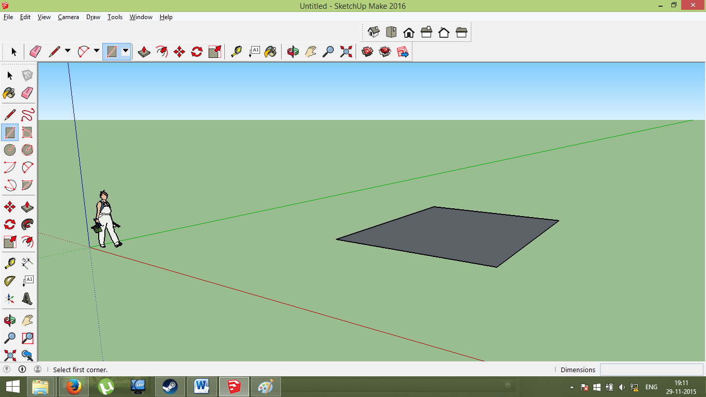

* Extrude the rectangle from the rectangular surface using the “Push/Pull” tool.

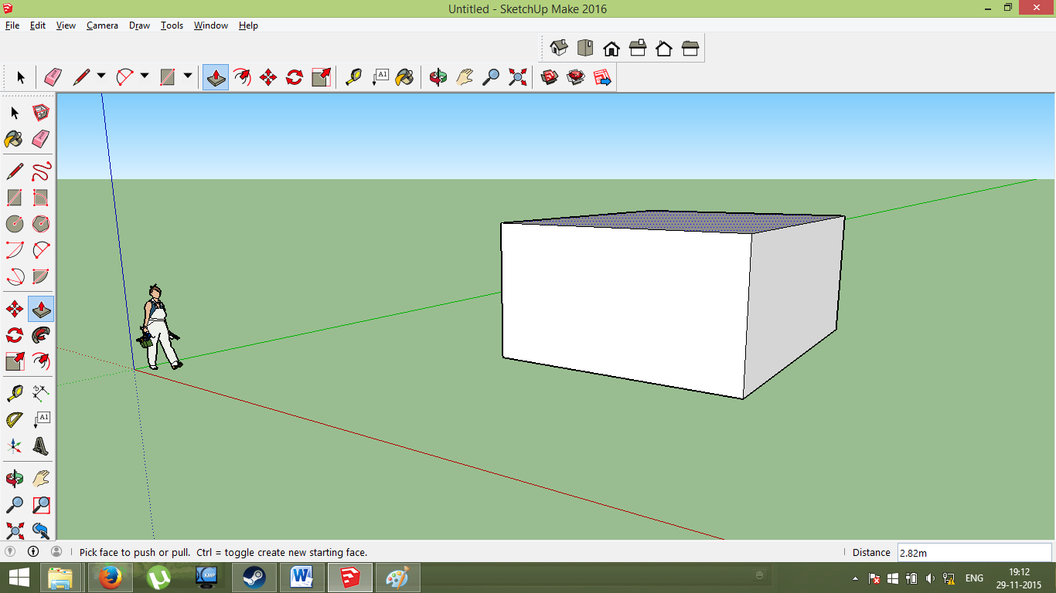

* Extrude the rectangle from the rectangular surface using the “Push/Pull” tool.

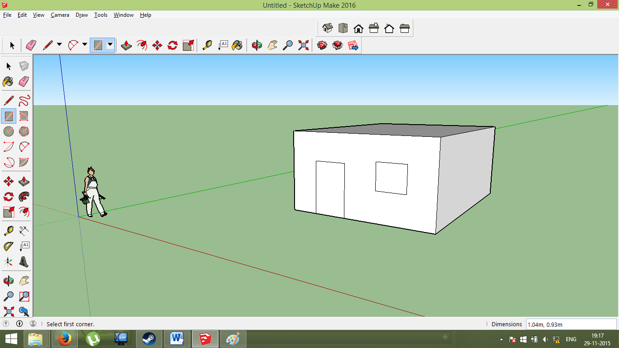

* Use “Rectangle” tool to draw door and window and right click on their surface to erase.

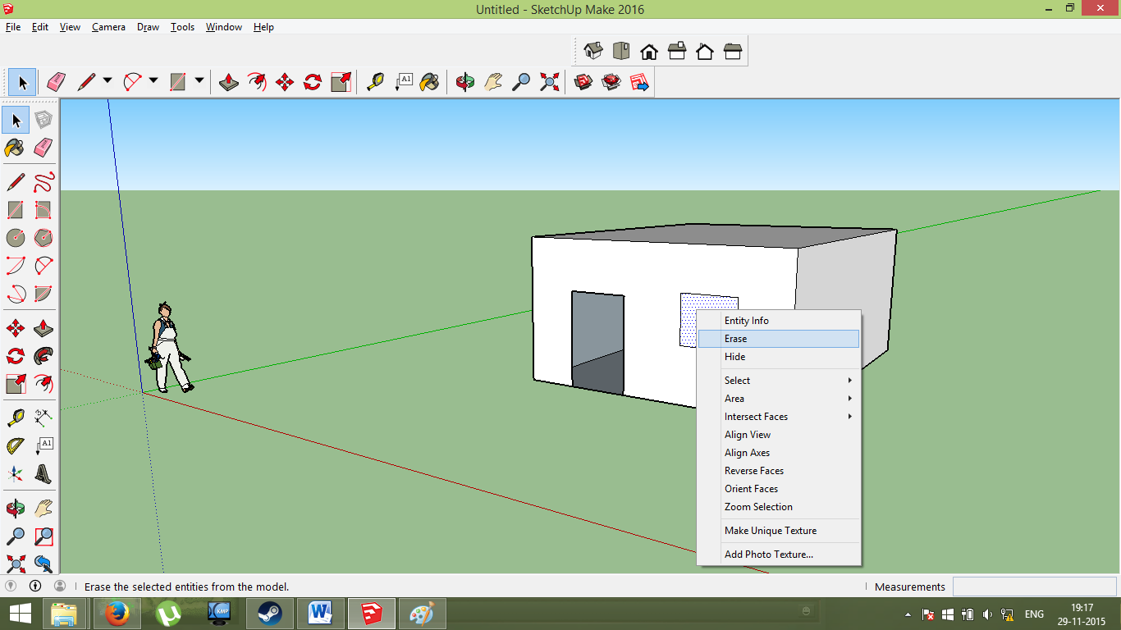

**COMPONENTS**

* **Window:**

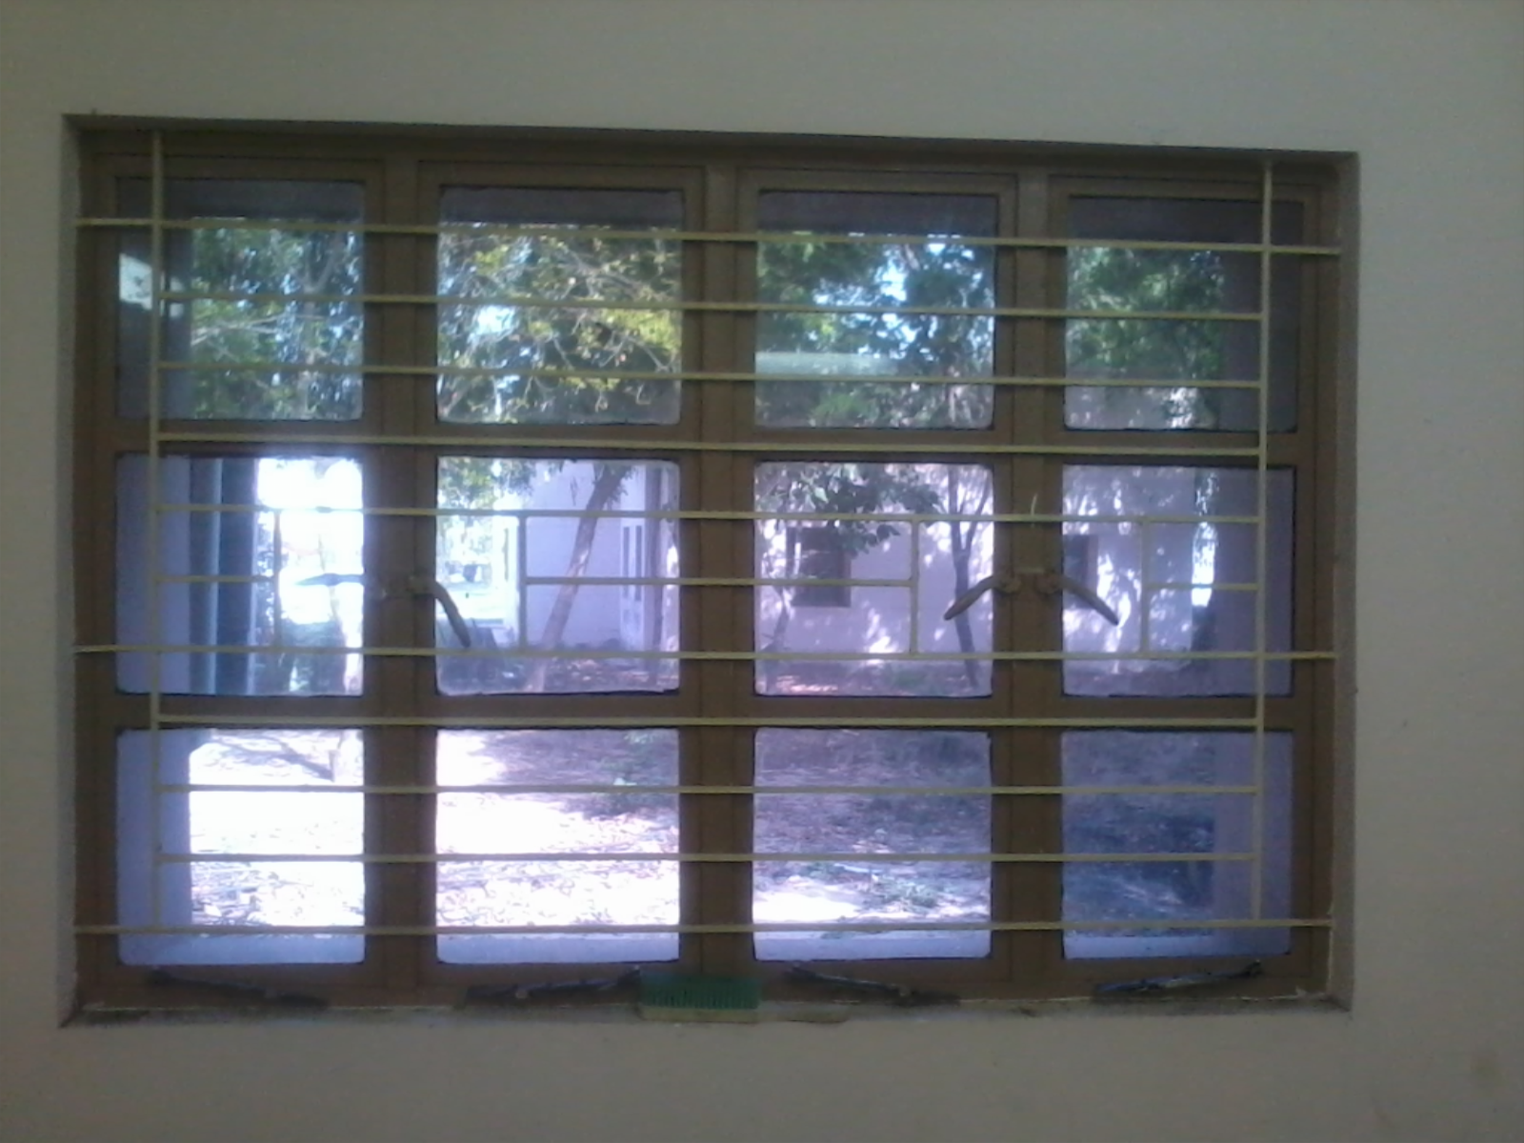

* **Tree:**

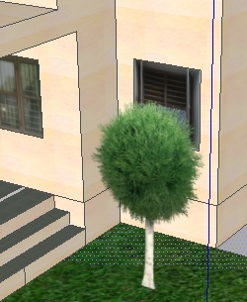

* **Lamp-post**

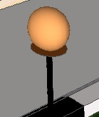

* **Door:**

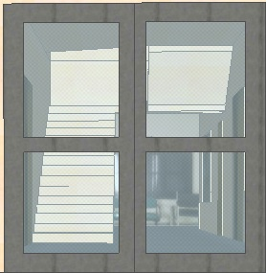

* **SketchUp model of Health Center**

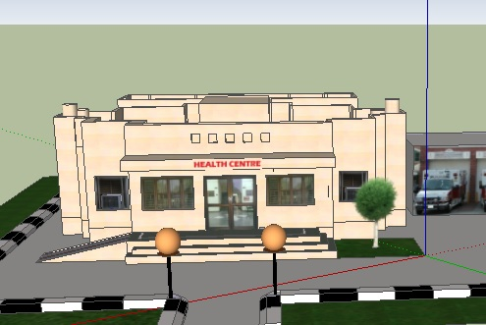

**SCENES**

* **Scene 1:**

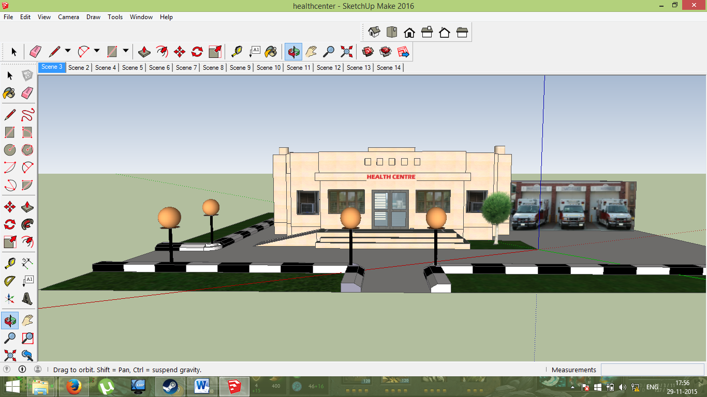

* **Scene 2:**

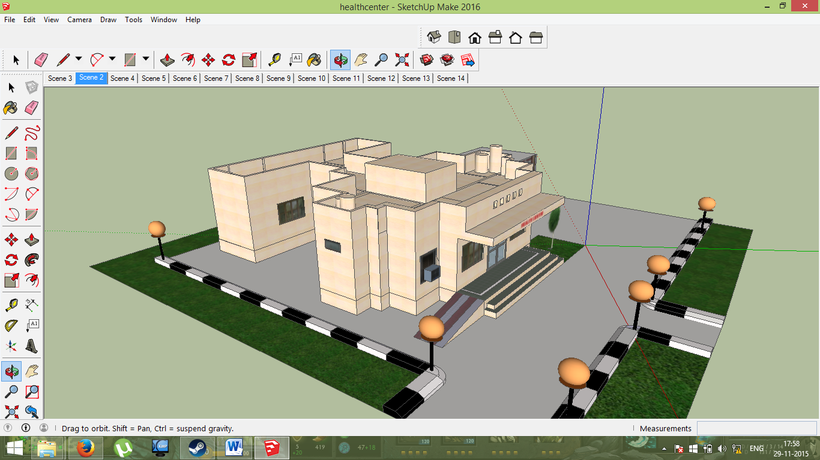

* **Scene 3:**

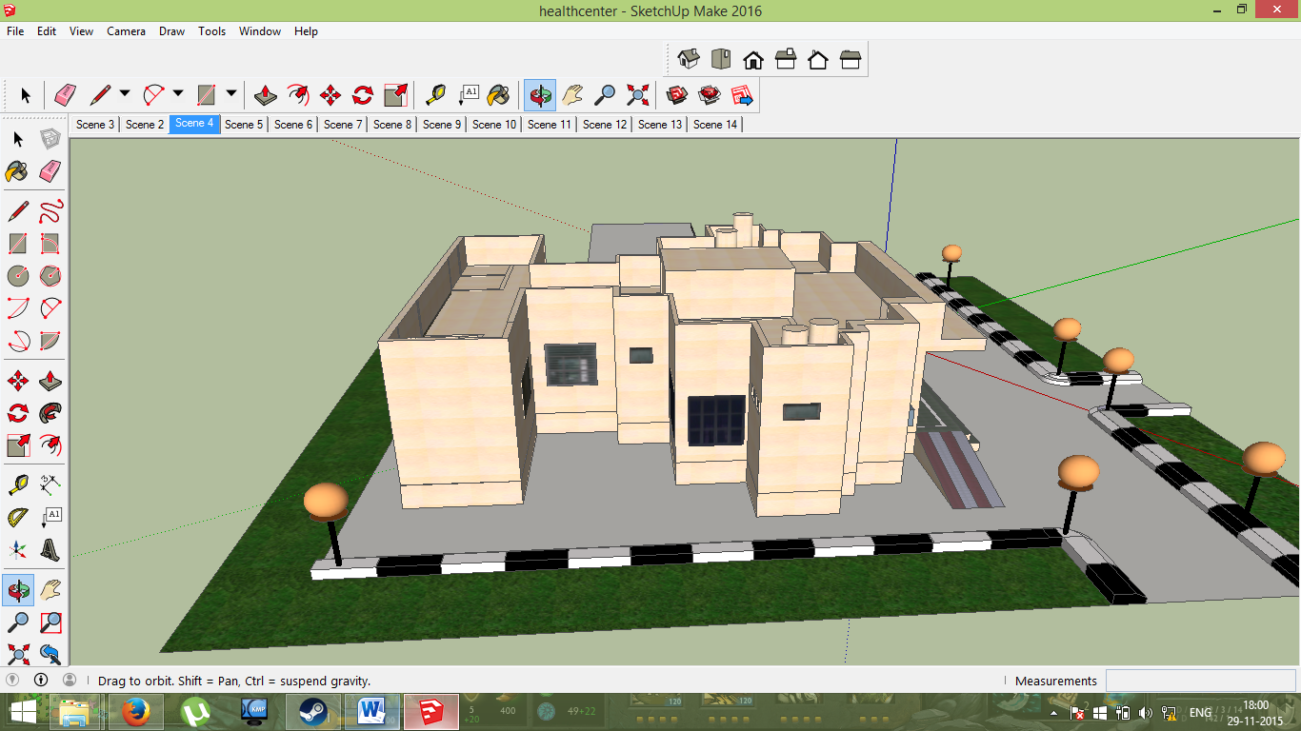

* **Scene 4:**

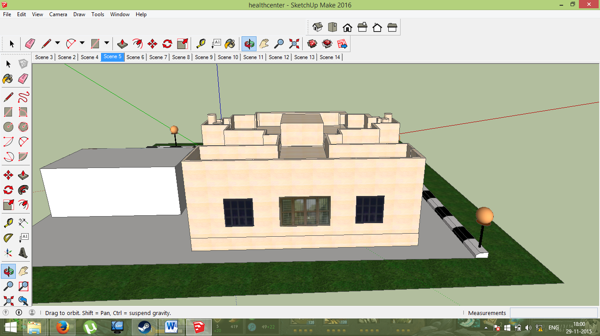

* **Scene 5:**

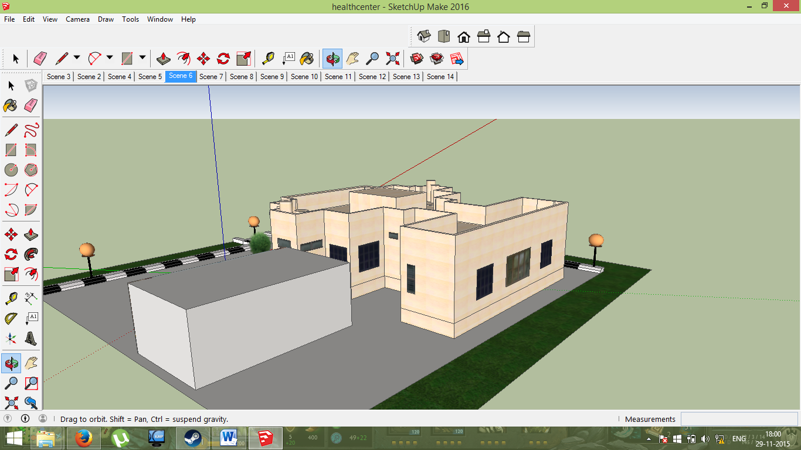

* **Scene 6:**

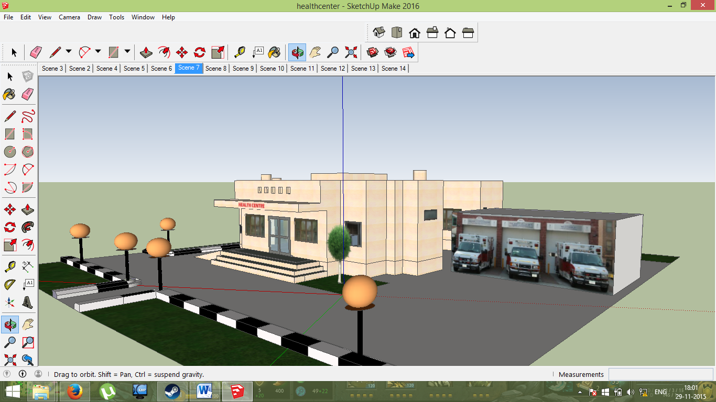

* **Scene 7:**

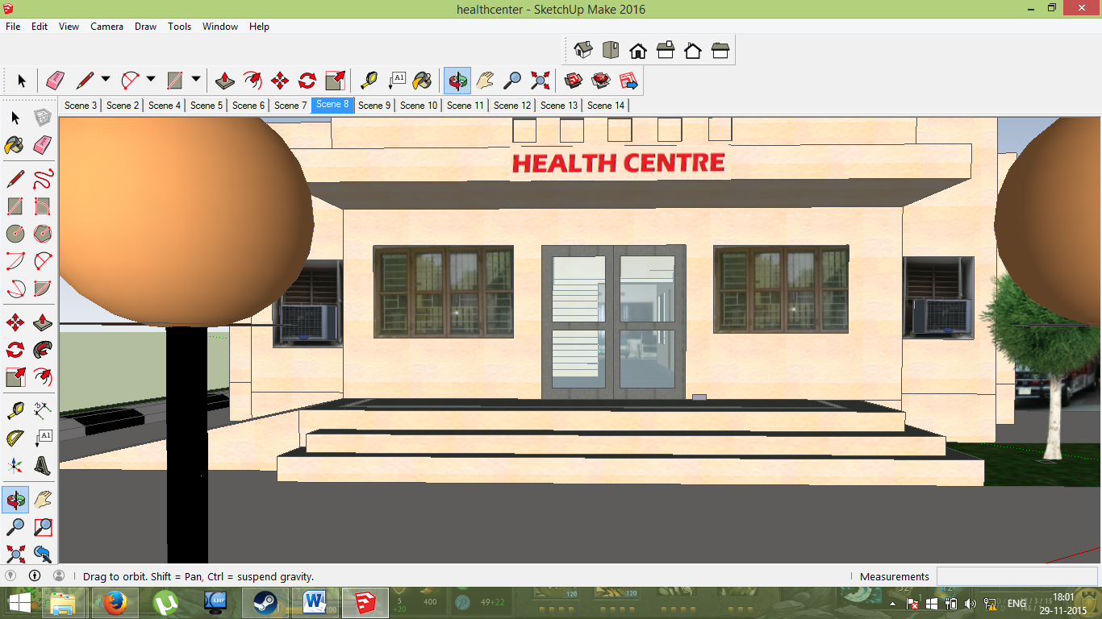

* **Scene 8:**

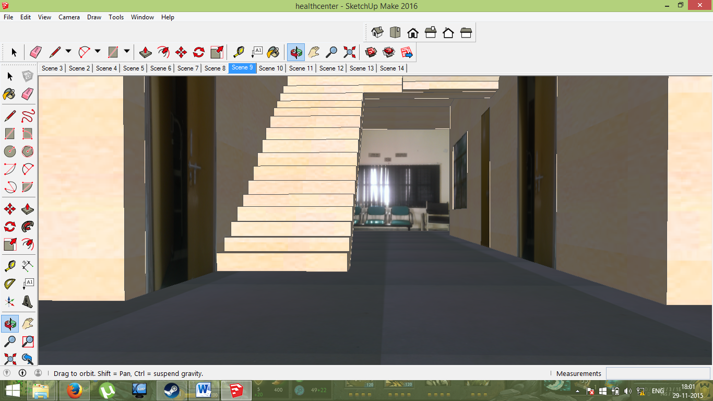

* **Scene 9:**

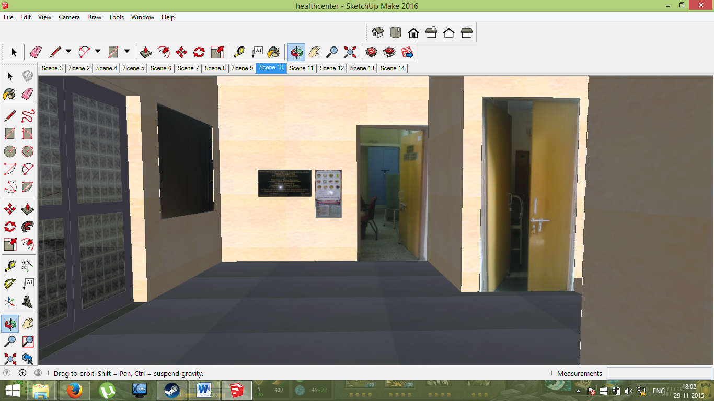

* **Scene 10:**

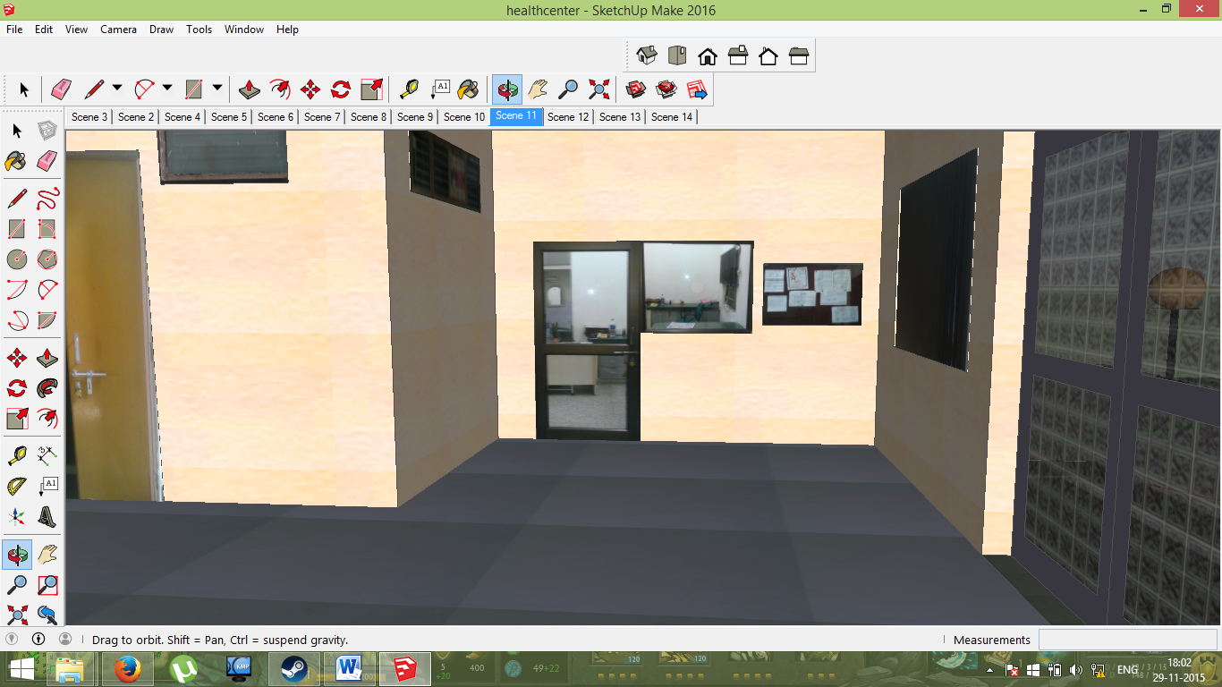

* **Scene 11:**

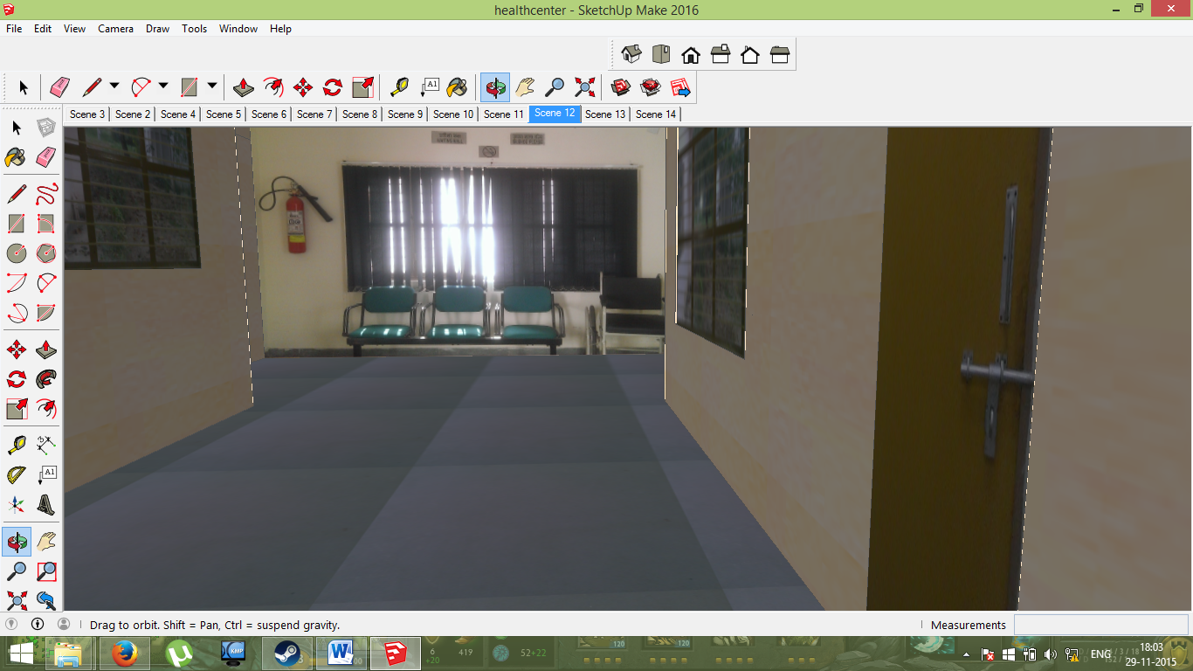

* **Scene 12:**

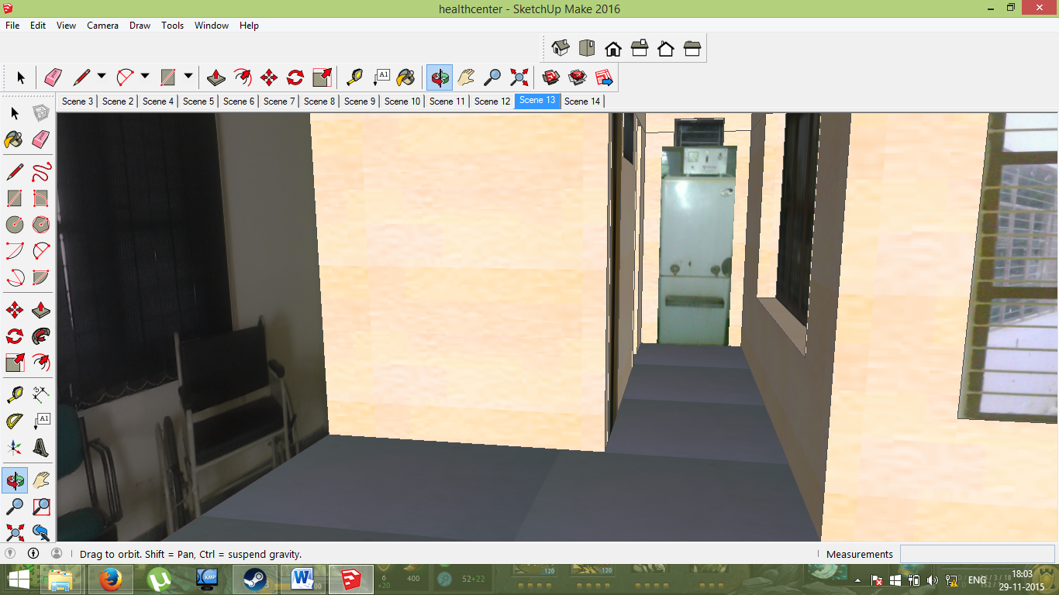

* **Scene 13:**

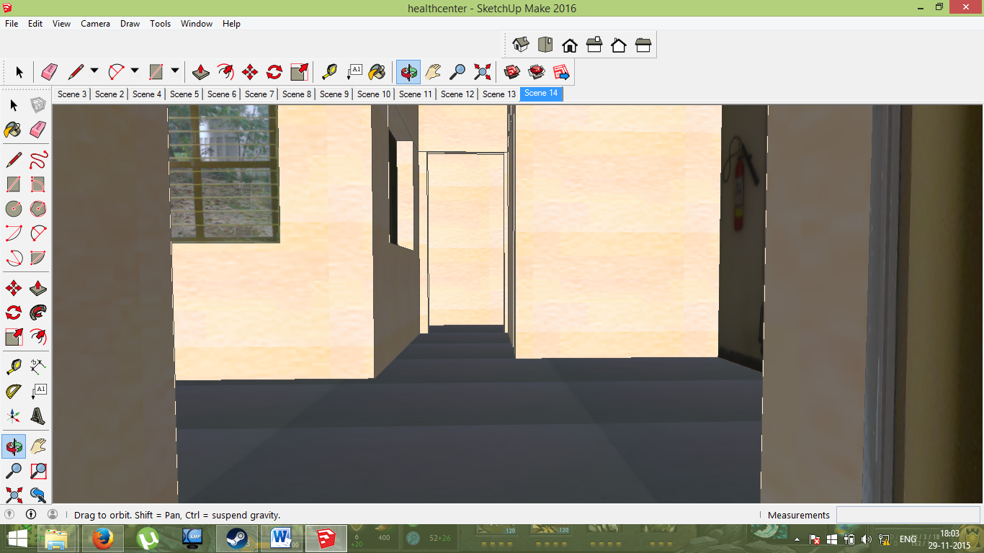

**WALKTHROUGH**

* Go to Camera -> Walk in SketchUp Make.
* Use the arrow keys (Up, Down, Left, Right) and the scroll button of mouse to navigate the health center area.